**Student table**

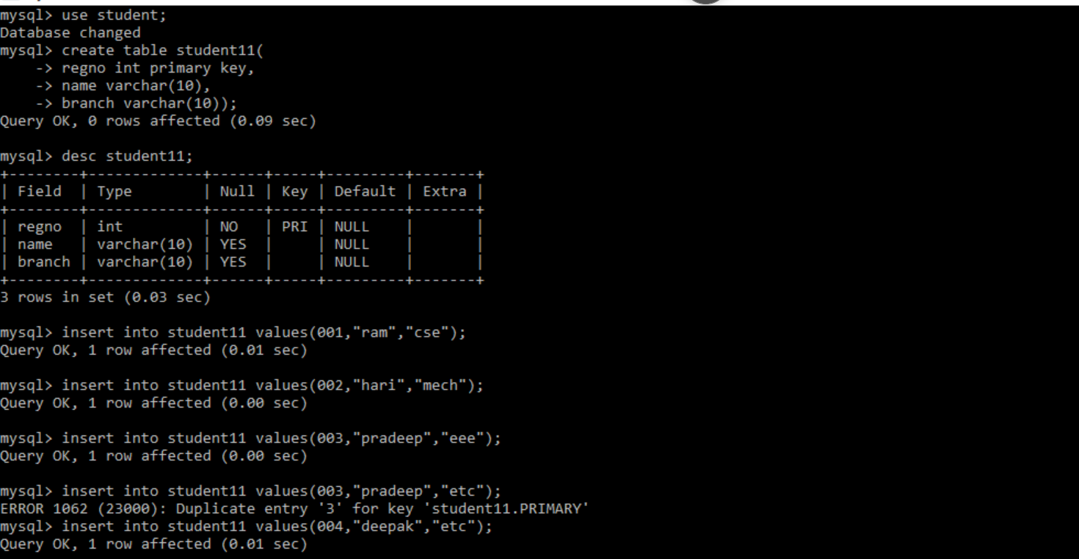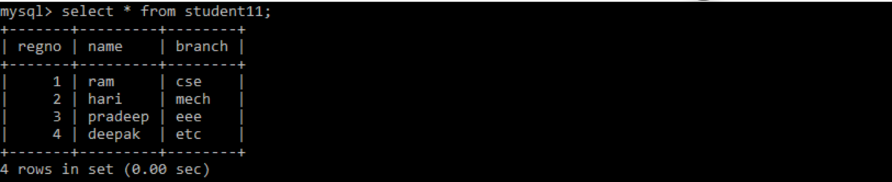

**Query for getting a register number of student by name pradeep**

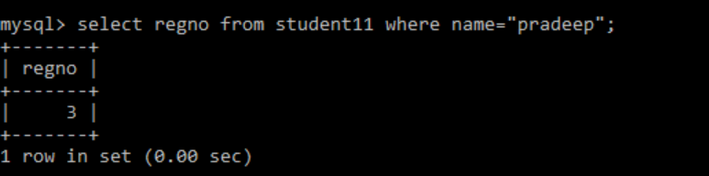

**Select branch and name of all the students**

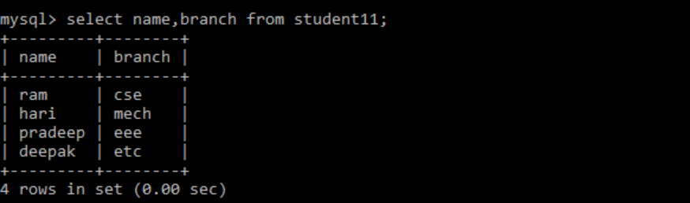

**Getting a count of records**

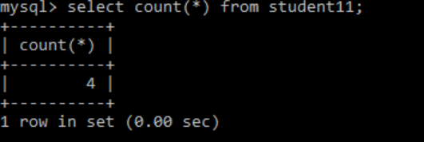

**Adding a address field to a table**

